PARISH OF WISLEY WITH PYRFORD
PAROCHIAL CHURCH COUNCIL
Meeting of the Parochial Church Council held at the Church of the Good Shepherd on 11th October 2021

Present : Reverend Canon Nicholas Aiken, Joanne Attrill, Anthony Bligh, Mike Brown, Claire Clough, David Dallison, Diane Davidson, James Fife, Jeremy Gidman, Pauline Langfield, Guy Meakin (Treasurer), Chris Newell, Andy Pearce, Reverend Mark Potter, Matthew Ryan, Claire Williams, Ian Wishart, Katharine Wright and Steve Chalkley (Secretary).

Robert Hewitt also kindly attended to give information on the activities of the Charities Review Group.

- APOLOGIES FOR ABSENCE
Apologies for absence were received from Katharine Gervasio and Linda Knowles.

2. MATTERS FOR PRAISE
- Men’s Curry Night.
- Women’s Forum – well attended.
- Holiday Bible Club – 145 attendees
- Suzanne - taking Youth Club bowling (large attendance).
- Harvest Service on Sunday – 184 attendees
- Archdeacon’s talk at St Nicholas and Wisley.
- Weddings – these have started again. 3 held including Becky Davidson.
- Holiday at Home. Well appreciated.
- Tim Pearce’s Funeral
- Down Memory Lane.
- Open the Book Assemblies.
- God’s Girls.
3. BIBLE READING
Mark read Psalm 98, “Sing to the Lord a new song…”

4. MINUTES OF THE LAST MEETING
The Minutes of the meeting held on 19th July 2021 were approved.

5. MATTERS ARISING
Anthony has started at St Mellitus College and it is going well. Anthony commented that he is enjoying the course.
The 10am Sunday Service will be the only service on Boxing Day.

- CHARITIES REVIEW GROUP RECOMMENDATIONS
Robert Hewitt attended to report on the Charities Review Group’s activities and recommendations. He said that the terms of reference for the group are to advise the PCC on which charities to support, as well as providing some support for the charities. They provide recommendations to the PCC every 3 years, and keep tabs on supported charities to check that the funds are being well used. A Local Community Fund was created to support small local projects. The general view is that the charitable purposes must be in line with our parish vision, and it is good if there is participation by parish members in the charity. The Review Group received 8 applications for support, whereas we only formally support 3 – namely one overseas, and two UK. The Group’s deliberations and recommendations as provided by Robert are pasted below:

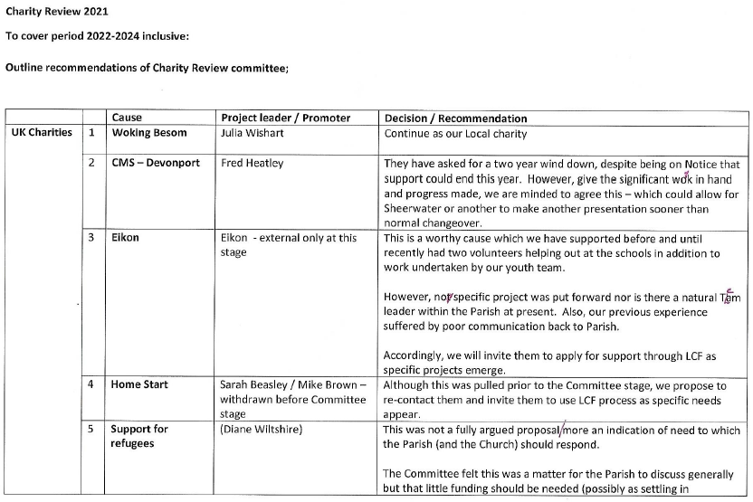
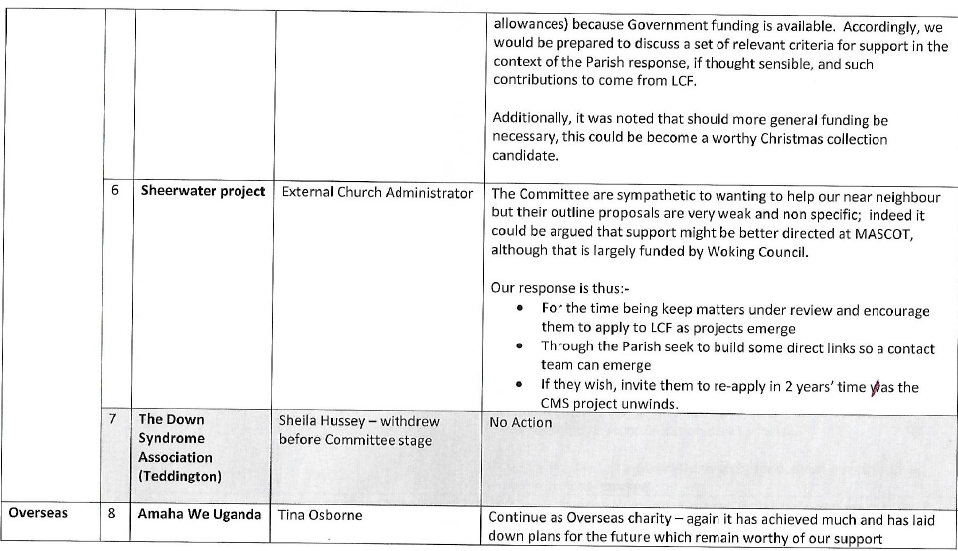
In summary, the recommendation is to continue supporting Besom, CMS-Davenport, and Amaha We Uganda, and to support other charities via the Local Community Fund as appropriate. The PCC agreed to this.
Robert mentioned that he would like one more volunteer for the Review Group if possible. Robert then left the meeting.

- FINANCIAL MATTERS
Guy had previously circulated a Financial Report. He pointed out that the estimated deficit is now ~£17k, versus a budgeted deficit of ~£19k. He also drew attention to ‘Note F’ concerning Anthony’s salary increase from 1st September. He also informed the meeting that HSBC are introducing bank charges from 1st November – including a monthly fee and a 40p charge for each processed cheque. He estimates that the total cost should be under £100 p.a.
Guy then gave an update on the Parish Giving Scheme, as follows:
- 7 people had signed up to begin payments in October: all had opted for annual inflation.
- 2 people had signed up to begin payments in November: neither had opted for annual inflation.
- 8 of those signing up are Members of the PCC. They were thanked for their assistance in this trial of the PGS.
- 2 people had increased their monthly donations. 1 person, who was an occasional giver, is now a regular donor.
- 2 people had forgotten to cancel their Standing Orders: one had asked for a refund, the other had generously declined the offer of a refund.
- £850 had been received from the PGS on 8 Oct 21. We are due £212.50 in Gift Aid by the end of October.
- Annette is very pleased with the Scheme
The PCC approved in principle the Parish's full participation in PGS. Members agreed that Annette and Guy would collaborate on a rollout plan that takes account of Annette’s workload, especially around year-end: this might mean postponing rollout to February-March 2022.

- DEANERY SYNOD INFORMATION
Chris Newell said that there was not much to report. He said that elections had taken place in which he voted, but results are still to be published. After the meeting, Chris circulated the agenda of the meeting to be held on 18th October. The agenda includes ‘green issues’ and an election update.

- NEW PARISH VISION
A draft of the new parish vision had been circulated prior to the meeting. There is no radical change of emphasis. The new strapline is ‘To Know Jesus And Make Him Known Every Day.’ Andy Pearce mentioned environmental awareness, and Nick said that an inspector for environmental issues is being sent from the diocese. There is a line in the vision document under ‘Discipleship’ which covers this, but it was felt that perhaps there should also be something on this under ‘Infrastructure’. Guy mentioned that perhaps there should be mention of the website and parish magazine under ‘Engaging Community’. Steve thought that perhaps there should be something to cover racism and ethnic minorities. Others thought that maybe there should be some mention of LGBTQ and the poor.
Nick said that the Vision will be put on the agenda for the next meeting.

- PRAYER AND REFLECTION
A time of open prayer was held.

11. BIKE RACK PURCHASE
Linda Knowles is looking into costs for a bike rack to be secured to the container at the back of the church.

12. HELPING OTHERS
It was agreed that ‘Helping Others’ (led by Tina Osborne) be formally recognised as a church group, so that it is covered by the church’s insurance.

13. CO₂ MONITOR
Matthew Ryan had circulated a paper on the use of a CO₂ monitor as an indication of the risk of COVID particles in the atmosphere. This should give a more objective/scientific basis for deciding if masks should be worn in church, as some people are very pro masks, whereas others are very anti – both sides thinking they are in the right. The CO₂ monitor has been purchased, and Matthew has results from 4 monitoring occasions in CoGS. Matthew said that these suggest that masks should not be obligatory, as CO₂ levels have all been less than 1000ppm, and mostly less than 800ppm at CoGS, which is indicated as relatively safe. Andy Pearce said that levels have been in the 700ppm range at St Nicholas. Pauline will use the monitor at Wisley to check levels there. Andy and Pauline commented that this whole issue has been very divisive. As far as CoGS is concerned, people will be verbally invited to wear a mask, but will be told that they do not have to. Anything further will wait on results from Wisley.

14. SUSTAINABILITY SURVEY BY DIOCESE
This was just to say that the diocese is sending someone to survey us on this issue.
Related to this, it was said that people should be encouraged to bring their own mugs for coffee, to save on the waste of disposable cups.

15. ADDITION TO ST NICHOLAS GRAVEYARD
Nick said that a benefactor with relatives buried at St Nick’s suggested buying the adjacent field to augment the graveyard which is nearly full. However, Burhill Estates was asking a high price of £30k, but Lord Iveagh of Burhill has now said that they will gift the field to the parish. As the people that maintain the churchyard are getting older, the benefactor has now said that he will gift ongoing human resources and finance for the upkeep – in the form of an endowment.

16. RECTOR’S REMARKS
None.

17. CLOSING PRAYER
The meeting closed at 10.05 p.m. with the saying of the grace.

(The next meeting will be held on Monday, 29th November 2021 at 8.15 p.m)

